ANNEX C
DESIGN OF STREAMERS/BANNERS AND SIGNAGE OF DOLE-ASSISTED LIVELIHOOD PROJECTS

- Livelihood Project
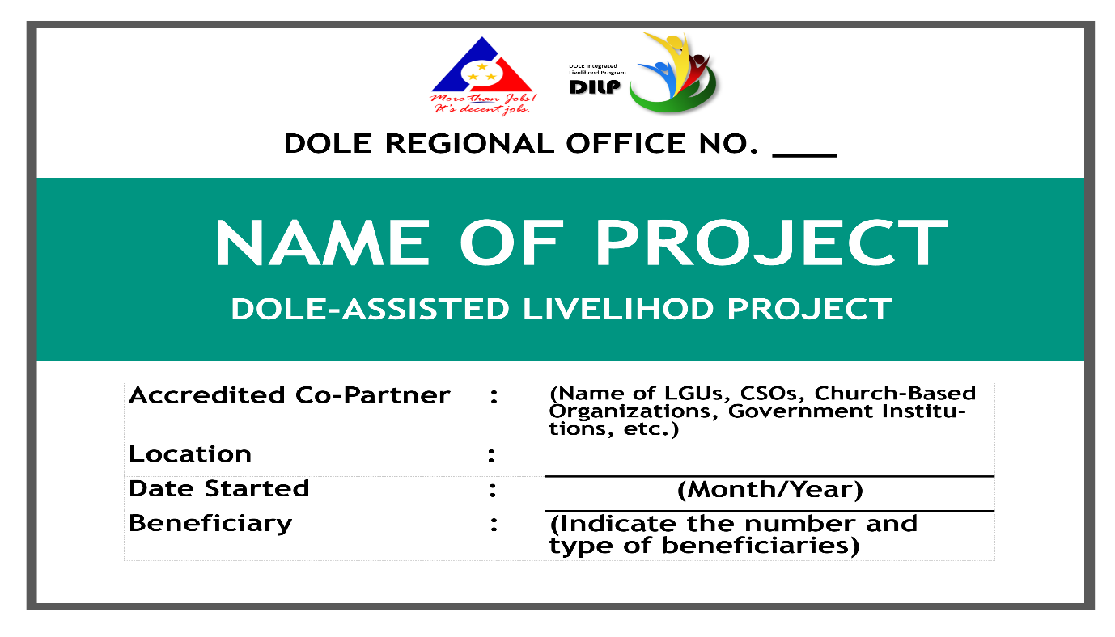
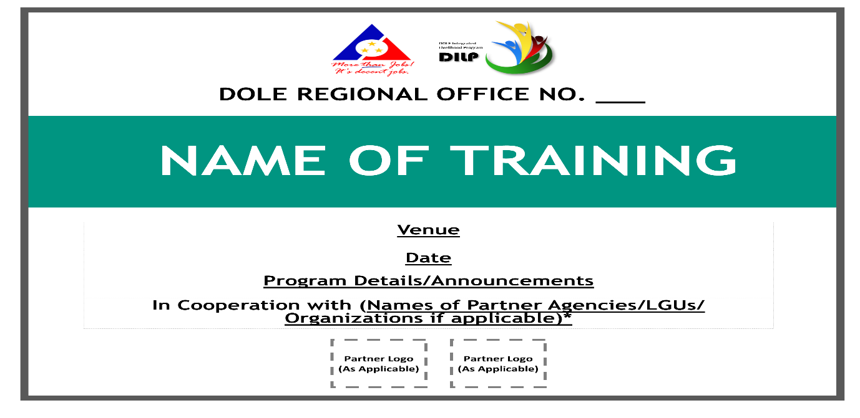
- Conduct of Training(s) for Beneficiaries

Note: (1) Use Trebuchet MS or Verdana for Font Styles. (2) Use Acronyms for the Name of Partner-agencies, if applicable.

